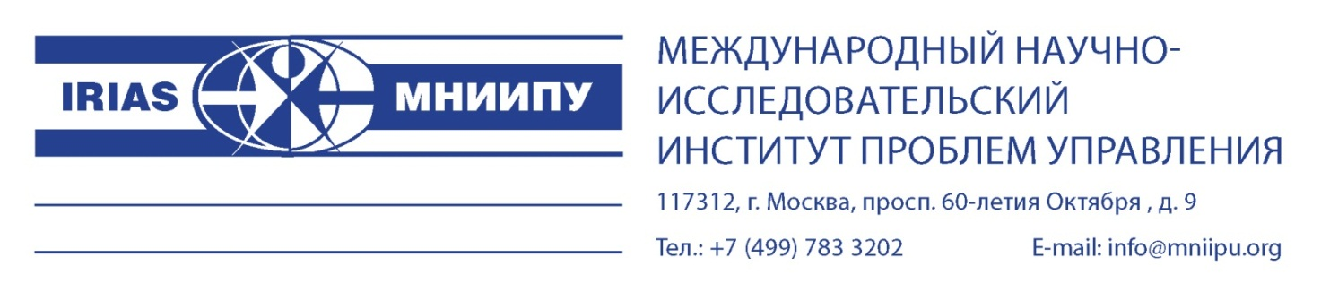

The International Intergovernmental Organization “International Research Institute for Advanced Systems” expresses its respect and informs about the preparations made for the implementation of the cultural program “Towards Time” (hereinafter referred to as the program) in the PRC in 2026-2027.
For the first time, it is planned to implement a large-scale rental of the exhibition program simultaneously in 8 cities of China (Beijing, Shanghai, Guangzhou, Hong Kong, Harbin, Wuhan, Chongqing, Tangjin), which together have a population of more than 132 million people. The exhibition period is 90 days, the exhibition area is 12,000 square meters in each city. The planned total attendance is more than 20 million people.
The program is based on authentic historical photographic documents about China at the end of the 19th century, obtained during the Russian expedition of scientists in 1874-1875 from St. Petersburg to China along the Great Silk Road and consists of exhibitions, publishing, advertising, scientific, souvenir, music, additional programs, a car rally and an auction. A special place is occupied by events related to the presentation and implementation of the album “China in photographs of Russian travelers of the second half of the 19th century”.
It is planned to publish gift copies: one will be offered as a gift from Vladimir Putin to Xi Jinping, one will be sold at auction in Hong Kong. The album is numbered, published in three languages simultaneously (Russian, Chinese, English) with a total circulation of 600,000 copies, A4+ format.
The program was highly appreciated by Russian President Vladimir Putin and Patriarch Kirill of Moscow and All Russia. Both wrote greetings in the album.
In one block with the album, an image catalog is planned about 8-10 companies from Russia, China, Mongolia, Kazakhstan (the countries through which the expedition took place) and a number of BRICS countries, with a circulation of 600,000 copies (Russian, Chinese, English).
Thus, historical photographs of the Silk Road (the first album) and information about modern companies within the framework of Xi Jinping's “One Belt, One Road” project (the second album) will be combined. The advertising space in this album can be sold at a special price.
To implement the program, two new joint-stock companies are being registered in Russia and Hong Kong. Budgetary funds from Russia and China didn’t involve. The program requires financing in the amount of $ 30,000,000 (in rubles, yuan), the funds will be used for the preparation and implementation of the program in Russia and China. The refund is due to the sale of entrance tickets, an album, an auction, an advertising campaign, souvenir and publishing products, and additional programs. The funds are required for a period of 13 months.
The Hong Kong company receives the proceeds and distributes the income after full payment of taxes.
The financial partner (investor) receives 30%.
The planned profitability for only two main items (tickets and publishing products) is more than $ 200,000,000.
The program is highly profitable, open, and fast-paying.
We suggest that you consider the possibility of your participation in the “Towards Time” program as a financial partner (investor).

